Changes request for Shipment release screen:

Date: 4 Jun 2014

1. Amend the M3 formula current value / 1000, the current Length , Width and height data downloaded is in mm unit.

M3 value in 3 decimal points,

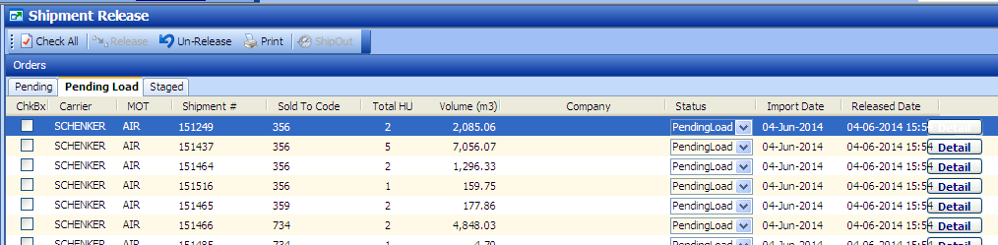

1. Detail view, to add M3 column ( after column Height) for each line and total m3 in summary

Detail:

